**WAGNER—**Letter F – 6/4 meter (Trumpet in F)

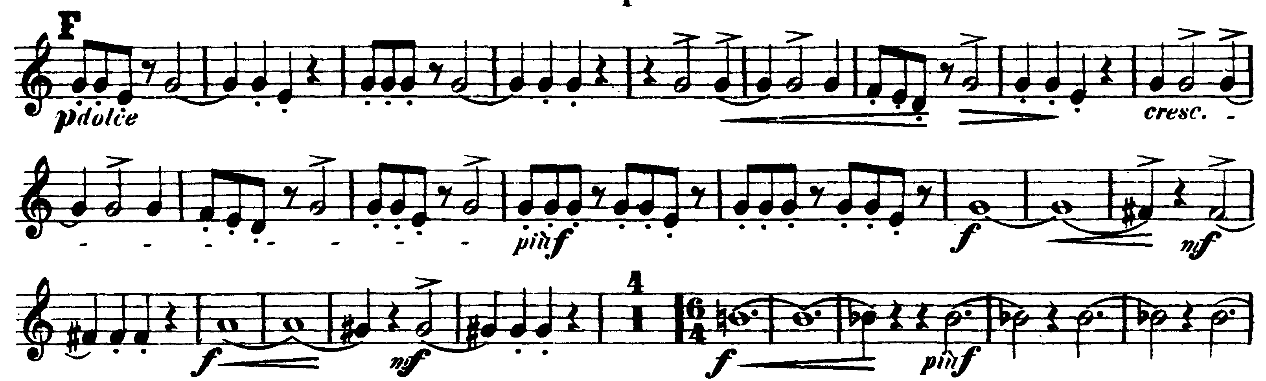

**TCHAIKOVSKY—**Mvt IV: Aa – Presto (*Trumpet in A)

